ULTRASONIC TESTING REPORT
Company/Client |  | NCOC N. V. |  | Project |  | ESKENE WEST KARABATAN |  | Location |  | Unit-360
Line No/Tag No: |  | A1-3600-PL-047-3"-C28-HC |  | Material |  | Alloy 825 |  | Día × Nominal Thickness |  | 3”x 5.49 mm
Procedure No: |  | QP-11-UTT-Q01 Rev 03  GOST 28702-90 |  | Calibration Block |  | CS Step wedge |  | Probe  S/N |  | D7906  1058416
 |  |  |  | Calibration block Range |  | 6.25-25.00 mm |  | Angle |  | 0º
Manufacturing Code |  | ASME B31.3 |  | Calibration Temp |  | +25º |  | Frequency |  | 5 MHz
 |  |  |  | Object Temp |  | +20º |  | Size |  | 11 mm
Acceptance Standard: |  | Acc. to the client specif. |  | Correction factors |  | n/a |  | Crystal |  | Dual
Surface condition |  | Coated |  | Couplant |  | UT Gel |  | Accuracy |  | ± 0,1 mm
S. No | Equipment/  Material Name |  | Manufacturer |  | Serial No |  | Calibration certificate No |  | Calibration Expiry date
 | DL-38 |  | OLYMPUS |  | 171421601 |  | BK-01-0674 |  | 20-03-2020
 | Step wedge calibration block |  | NDE-TECH |  | NDE-8363 |  | - |  | -
C3
C4
R4

Job description:

- UT measurements were conducted for thickness monitoring of pipeline.
- Echo-to-echo UT technique was used.
- UT thickness has been carried out on every 25×25 mm square.

25 mm
Column No
Row No
R1/C1
C2
C5
C6
….
R2
R3
25 mm
Notes:
N/A – not applicable.
FSH - Full Screen Height

Results
Item description | DIA(Ø) × Nominal Thickness, mm | Row No | Column No
Item description | DIA(Ø) × Nominal Thickness, mm | Row No | C1 | C2 | C3 |  | C4 | C5 | C6 | C7 | C8 | C9 | C10 | C11 | C12
Loc. 5 Elbow | 3” x 5.49 mm | R1 | 5.73 | 5.83 | 5.86 |  | 5.99 | 5.85 | 5.75 | - | - | - | - | - | -
Loc. 5 Elbow | 3” x 5.49 mm | R2 | 5.72 | 5.81 | 5.83 |  | 5.82 | 5.79 | 5.74 | - | - | - | - | - | -
Loc. 5 Elbow | 3” x 5.49 mm | R3 | 5.75 | 5.76 | 5.77 |  | 5.81 | 5.82 | 5.84 | - | - | - | - | - | -
Loc. 5 Elbow | 3” x 5.49 mm | R4 | 5.81 | 5.68 |  | 5.44 | 5.52 | 5.81 | 5.92 | - | - | - | - | - | -
Loc. 5 Elbow | 3” x 5.49 mm | R5 | 5.71 | 5.36 |  | 5.14 | 5.14 | 5.44 | 6.02 | - | - | - | - | - | -
Loc. 5 Elbow | 3” x 5.49 mm | R6 | 5.58 | 5.16 |  | 4.91 | 5.00 | 5.25 | 5.47 | - | - | - | - | - | -
Loc. 5 Elbow | 3” x 5.49 mm | R7 | 5.53 | 5.13 |  | 5.21 | 4.94 | 5.16 | 5.41 | - | - | - | - | - | -
Loc. 5 Elbow | 3” x 5.49 mm | R8 | 5.23 | 5.06 |  | 4.90 | 4.99 | 5.11 | 5.46 | - | - | - | - | - | -
Loc. 5 Elbow | 3” x 5.49 mm | R9 | 5.78 | 5.61 |  | 5.12 | 5.14 | 5.30 | 5.60 | - | - | - | - | - | -
Loc. 5 Elbow | 3” x 5.49 mm | R10 | 5.84 | 5.71 |  | 5.61 | 5.58 | 5.62 | 5.64 | - | - | - | - | - | -
Loc. 5 Elbow | 3” x 5.49 mm | R11 | 5.76 | 5.73 |  | 5.83 | 5.87 | 5.87 | 5.70 | - | - | - | - | - | -

Notes:
N/A – No access due to the size

Drawing
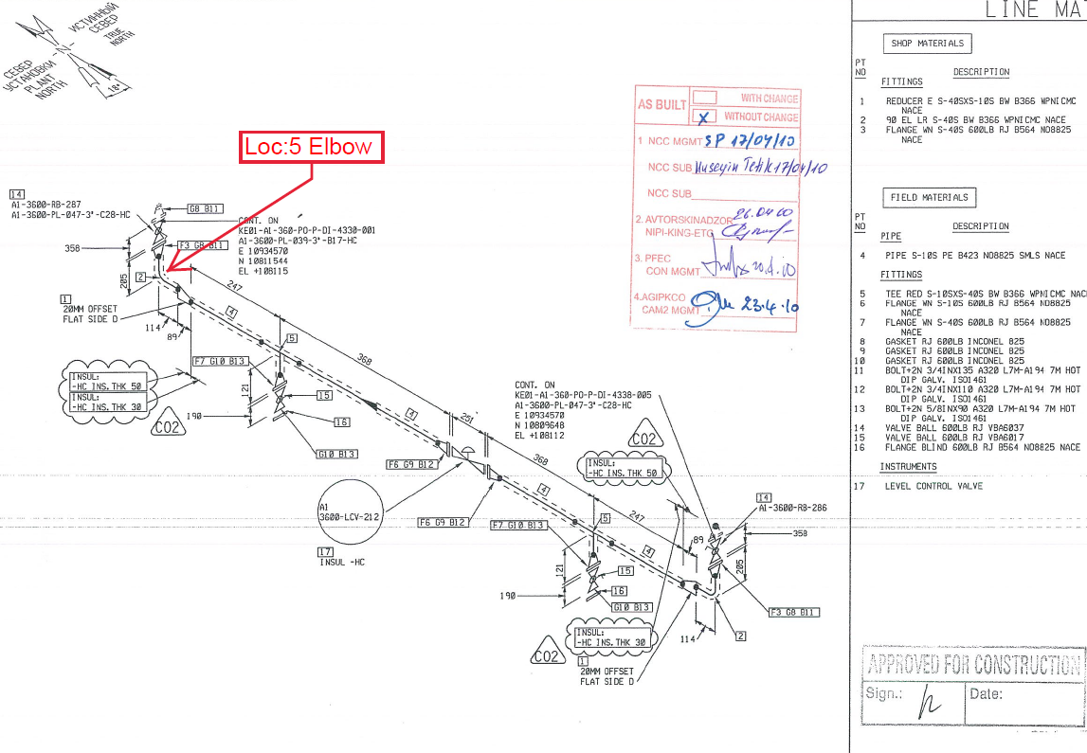
A1-3600-PL-047-3"-C28-HC

Examined by  UT L II cert. No 13180-2018-00 exp. date:11.07.2023 | Name: Ongarbayev Azimbek | Signature:…............................. | Date: 31-July-2019
Approved by  UT L III cert. No 1A 123/15  expiry date 29.02.2020 | Name: Shundryk Ihar | Signature: ................................ | Date: 31-July-2019
Client Representative: | Name: …………………………… | Signature: ................................ | Date: ……………………

